- Create online your account on this website : https://fo.visale.fr/#!/login/locataire
- Click on “Je suis LOCATAIRE ”
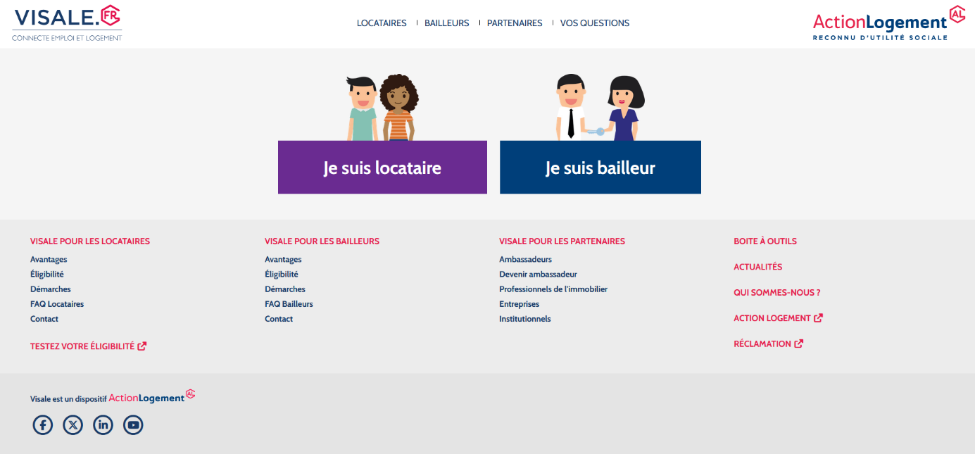

- On the part « Je n’ai pas encore d’espace visale » select « je m’inscris à VISALE »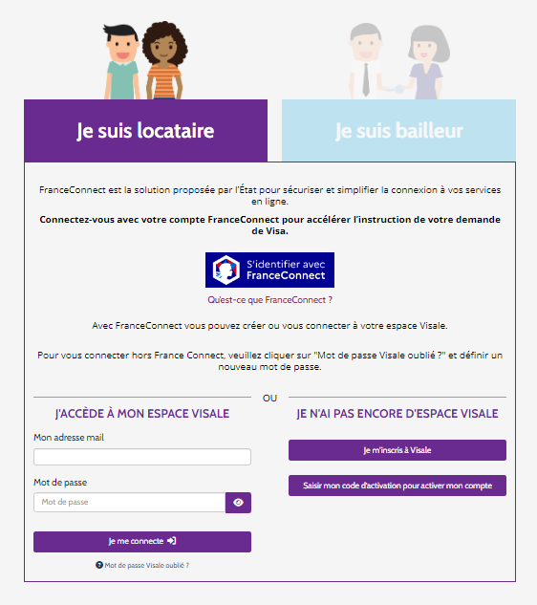4. 454.fv

- Register with your email address, create a password and select the information as it shows bellow. And select “Créer mon compte”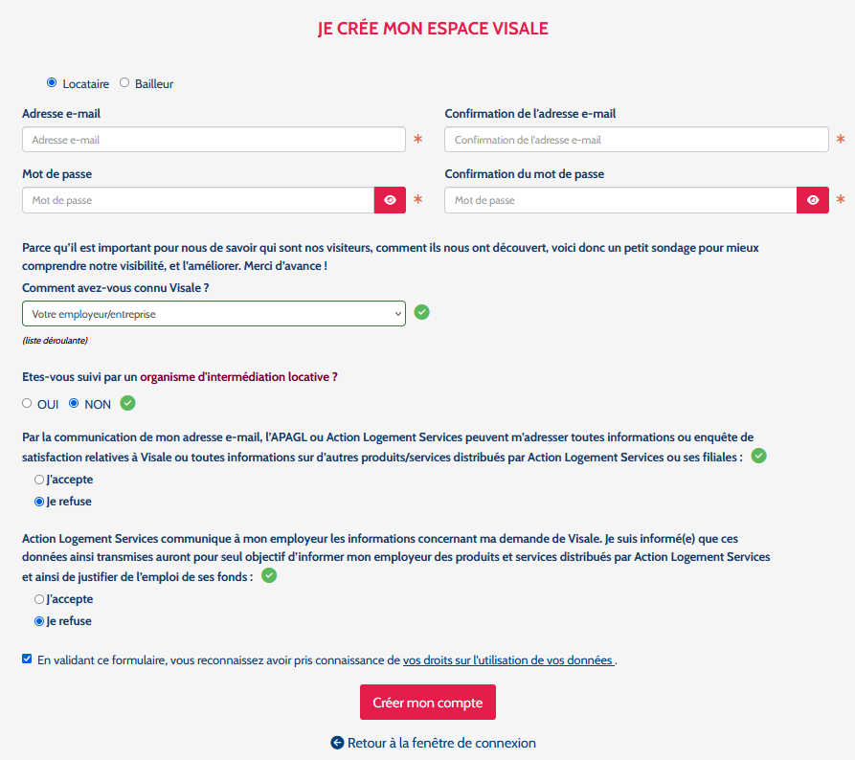

- Here click on « Demander un visa »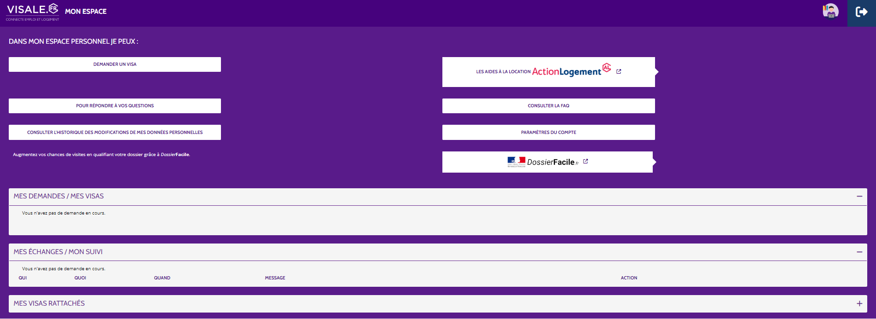

- File up the two first question as it shows bellow and file up the blank with your personnal information :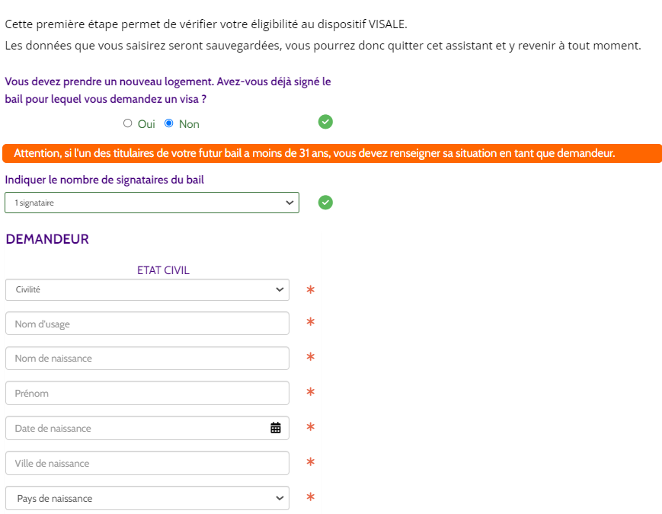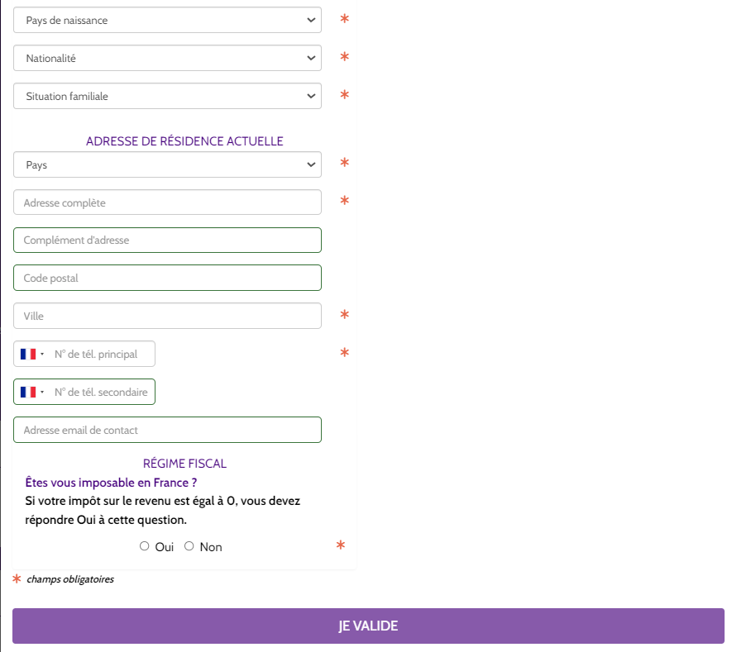
In the last question “Régime fiscal” please answer “No” and validate.

