APPENDICES

Creating a student account on the MSE platform

- Create a DES file using the following link:
https://www.messervices.etudiant.gouv.fr/envole/

- Then click on : "Demande de dossier social étudiant (DES)".
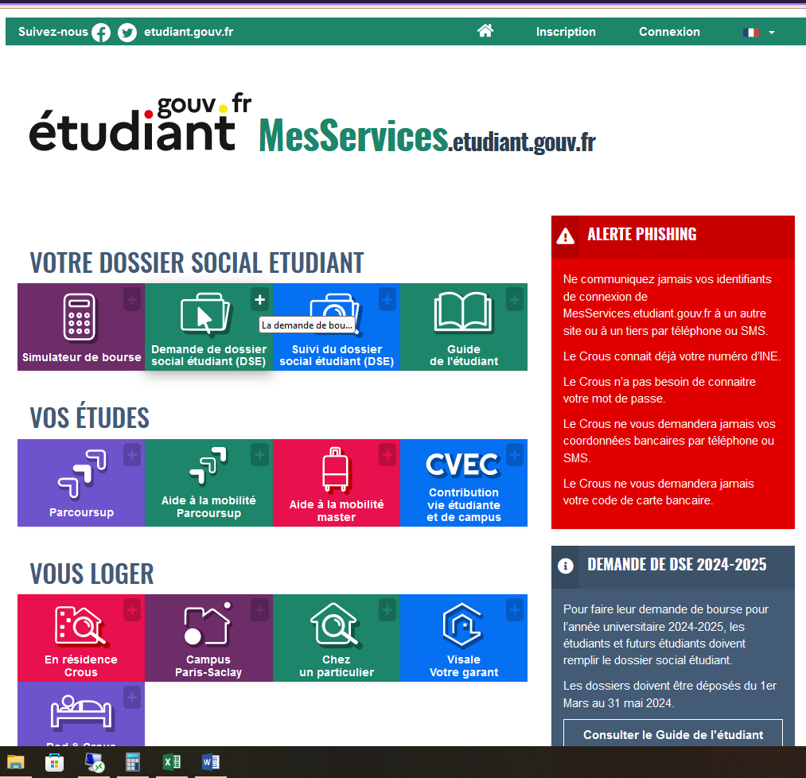

Then click on "S’identifier avec MesServicesétudiant.gouv.fr"

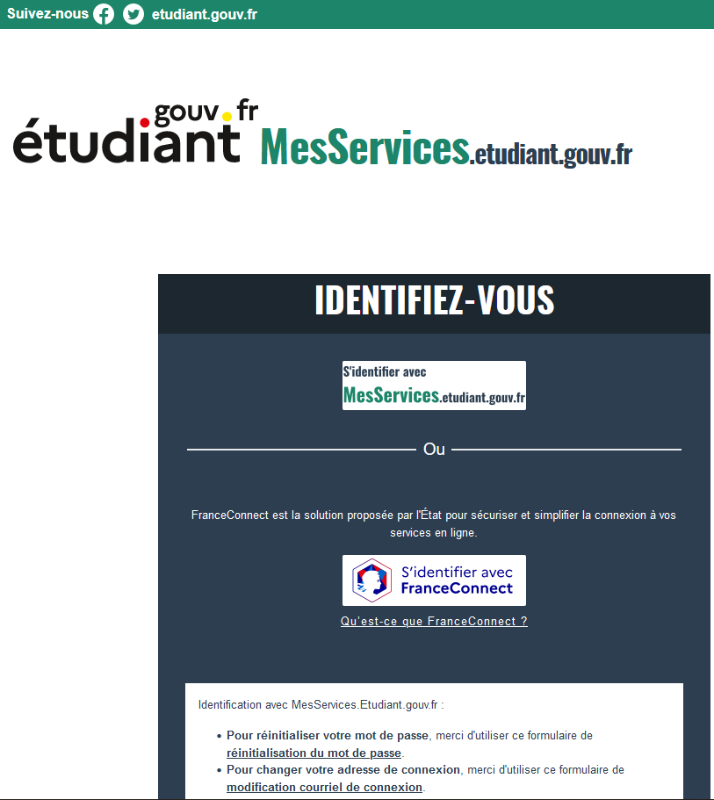

Click on the Registration Form link (If you do not have a "Mes Services" account)

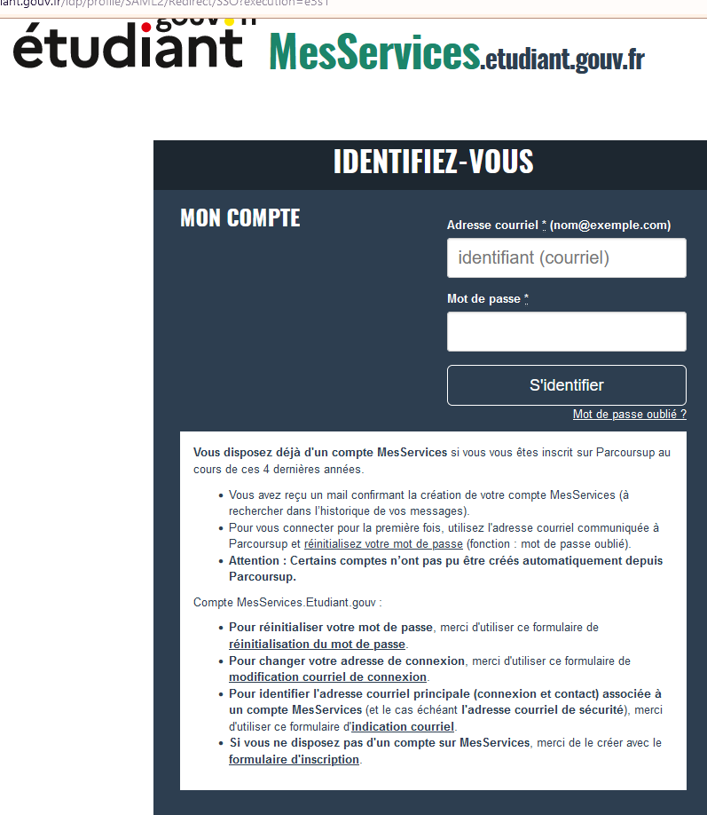

You will arrive on this page

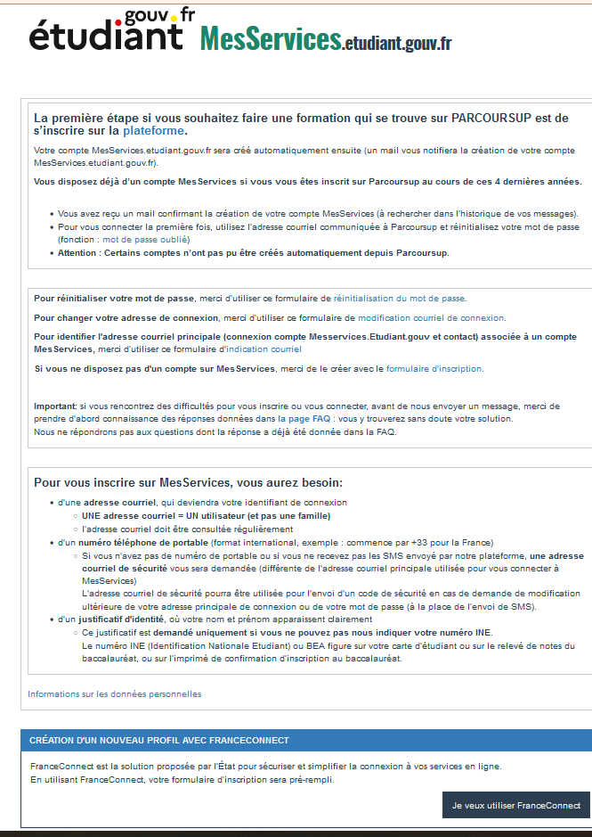

Scroll down until you see the following screen:

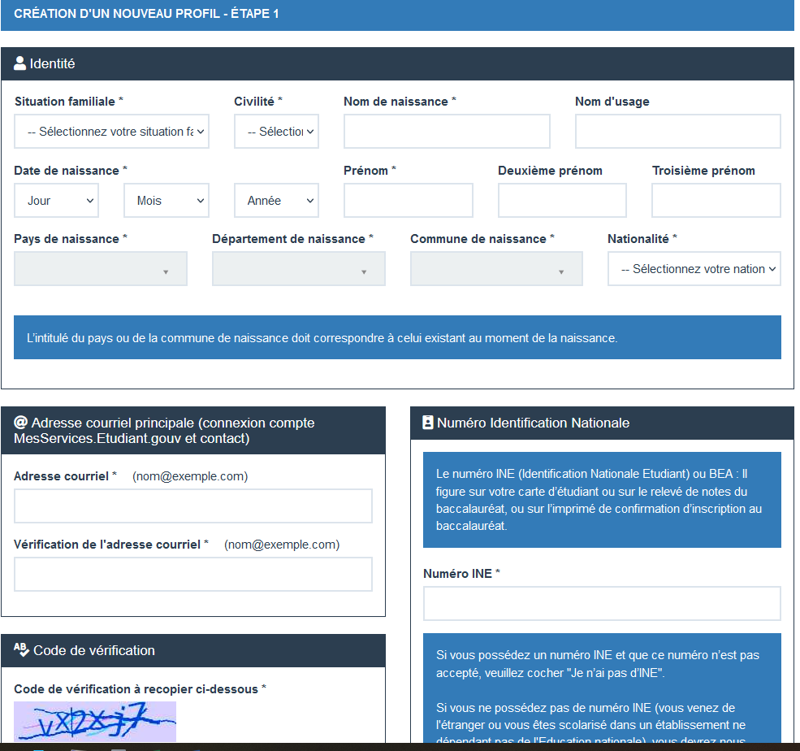

Complete all information

For foreign students, you do not have an INE number, so check the box " Je n’ai pas d’INE " and then on "Suivant"
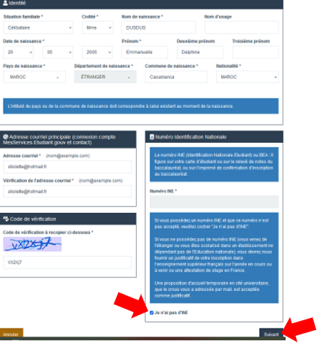

This screen appears. Click on "OK"

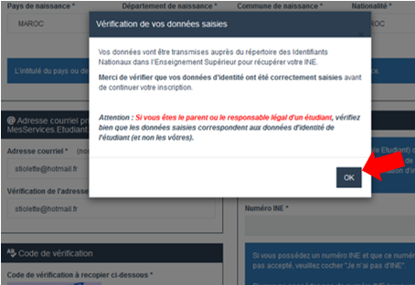

Then click on "Confirmer" :

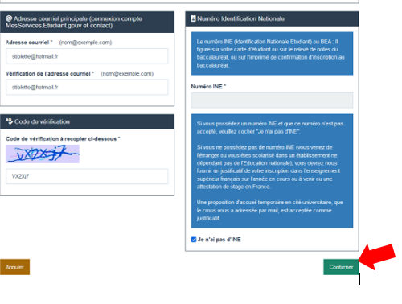

You will arrive on this page which asks you to wait

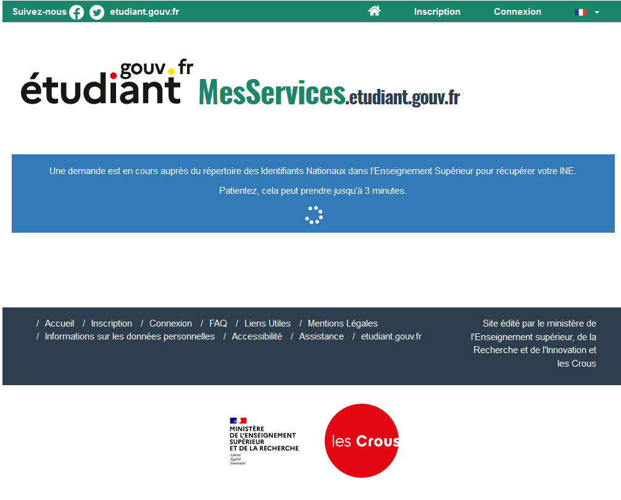
This takes you to the screen with the provisional INE to be given to you at the time of booking. Click on "Suivant"

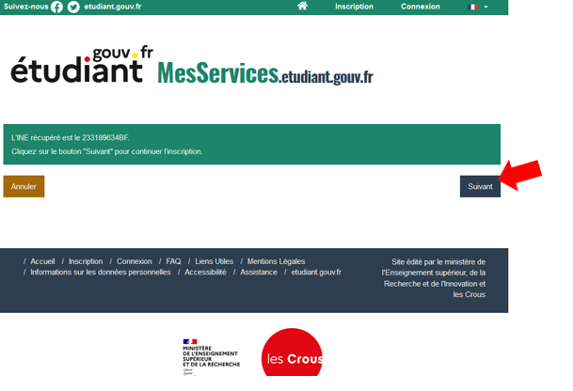

This e-mail will be sent to your mailbox with your activation code.

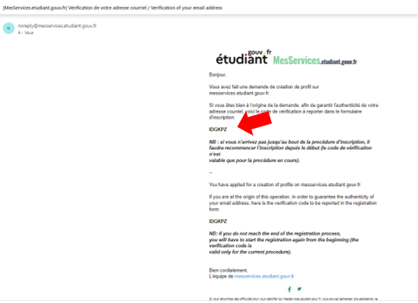
Then enter the identification code sent to you by e-mail, and click on "Suivant":

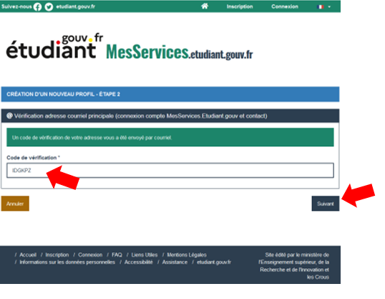
Complete the file

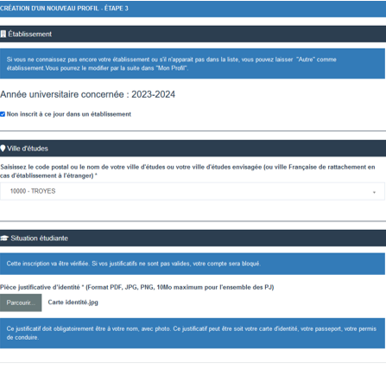
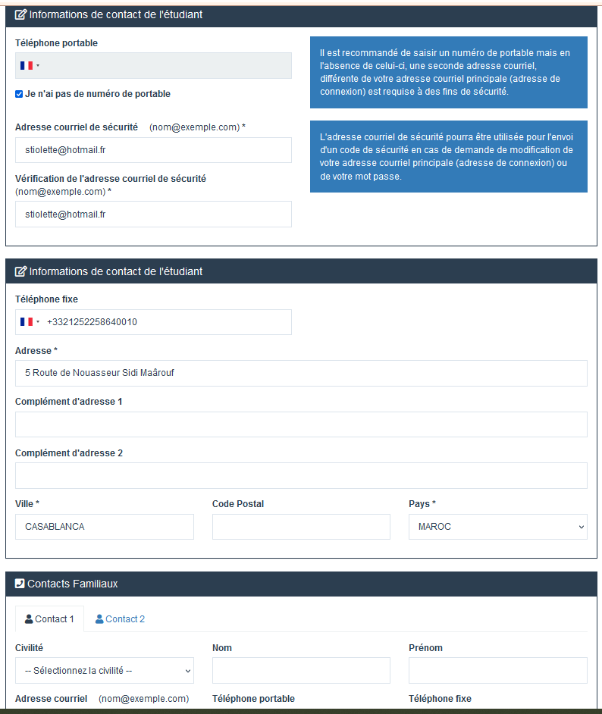

Click on "Suivant" at the bottom of the screen

You arrive on this screen

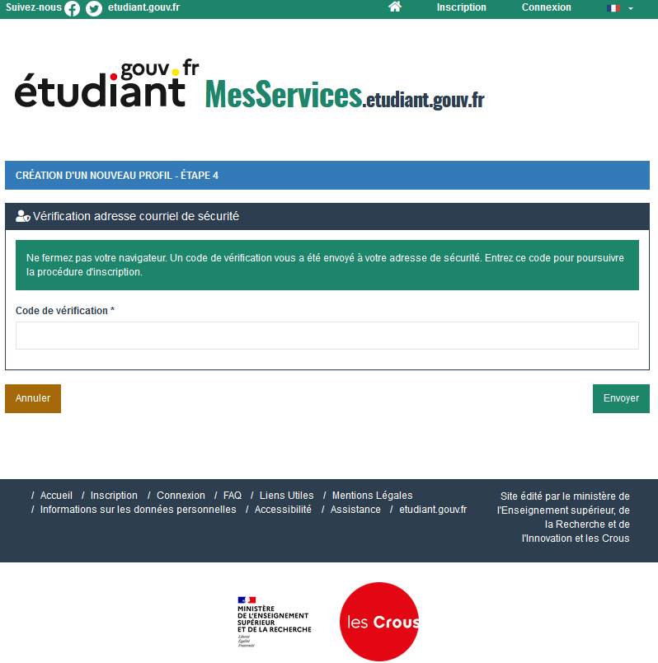

Copy the Code sent to you by e-mail or SMS, whichever you have chosen, then click on "Envoyer".

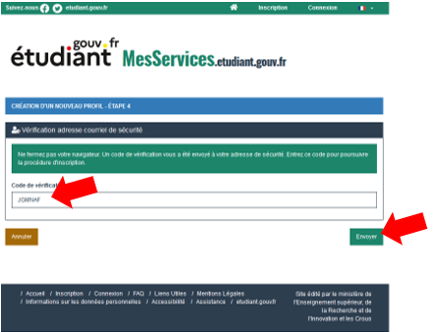

You will then still need to apply for a scholarship.

Click on "Je n’ai pas la nationalité Française ou Andorranne" then on "Suivant".

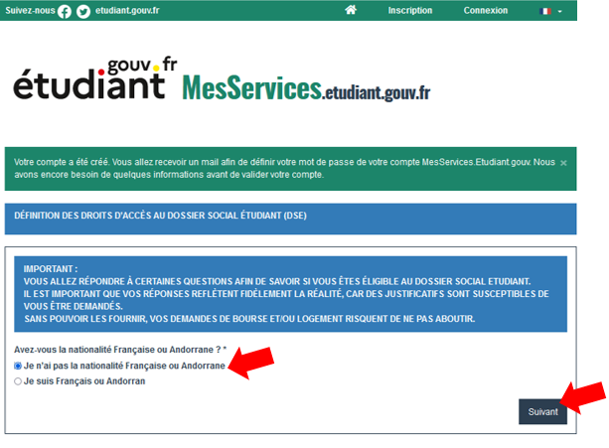

Then click on "NON" then on "Suivant"

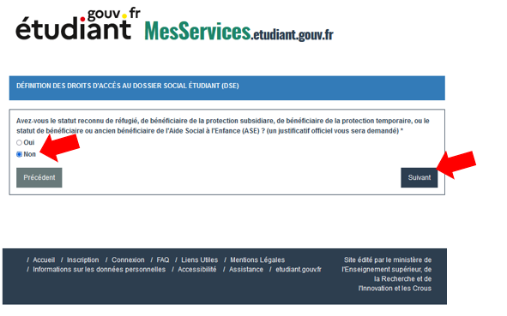
Then click on "NON" then on "Suivant"

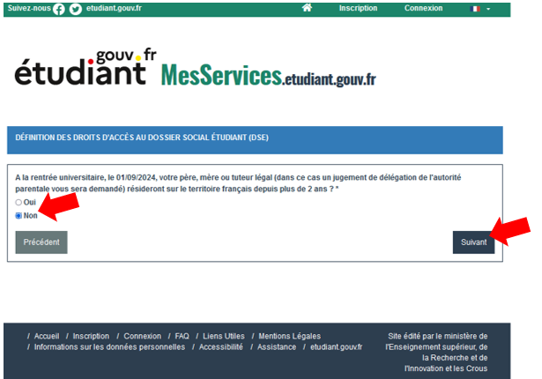

You will then be taken to a page where you will be told that you are not eligible for the grant.
Click on "Fin"

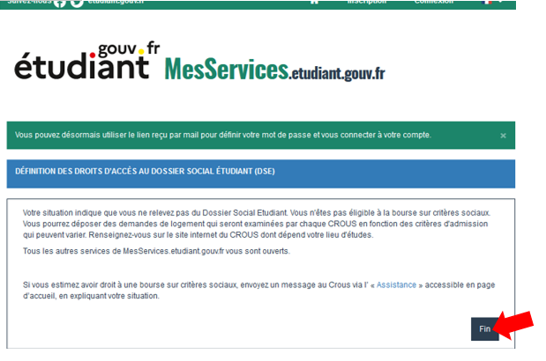
You return to the MSE platform login page.

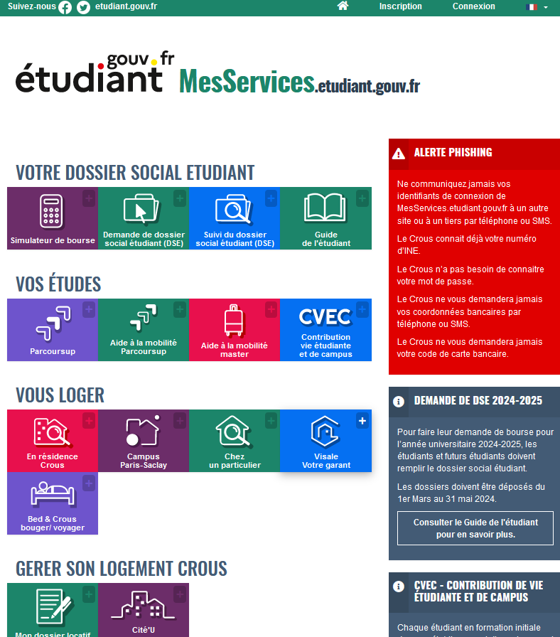
You will then receive the email below with a link that you must click to set your password to connect to the MSE platform.

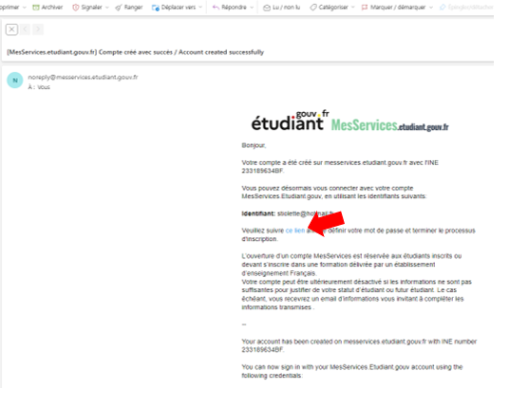
You must then create your password (if you wish, you can set it automatically).

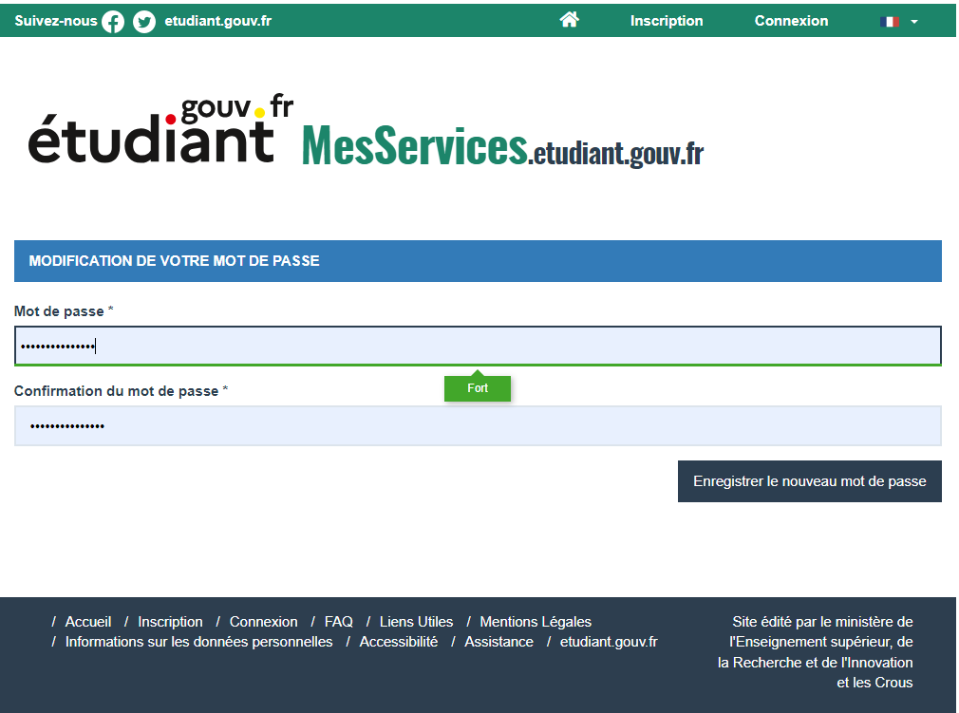

You will then be able to connect to MSE and all its applications.

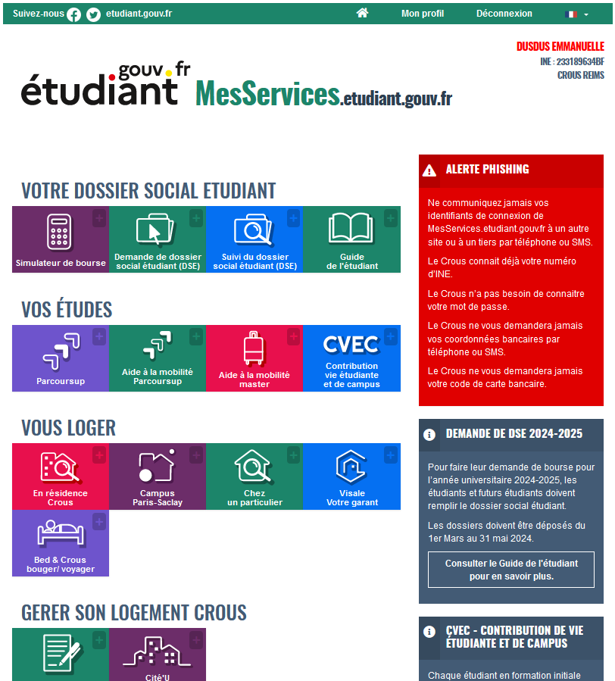

Creating a housing application on the MSE platform
- After creating your DSE file on the platform, return to the following link:
https://www.messervices.etudiant.gouv.fr/envole/

- Creating your housing request

- The CROUS manages the reservation request for students under agreement.

Once your file has been processed by CROUS, you will receive a confirmation e-mail. If you do not receive an e-mail, there is a problem with the creation of your DSE account.

2 - Validation of housing application

Once your application has been validated by CROUS, you will receive the following e-mail. Simply click on the link to pay the €100 advance.

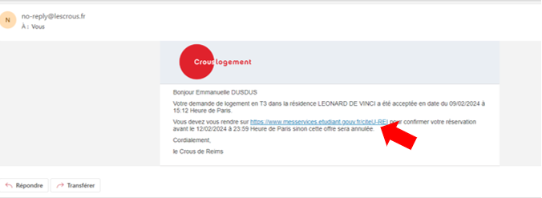

The link takes you back to the MSE website. Simply log in using your "MesServices" login and password.

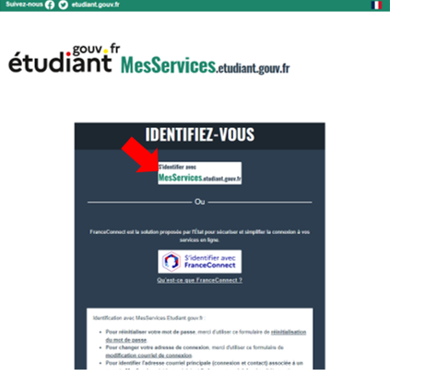

You will be taken to the next screen and asked to select “ Proposition de logement 2023-2024”.

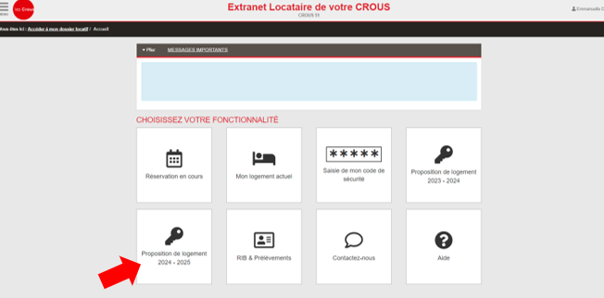

Then click on "Confirmer"

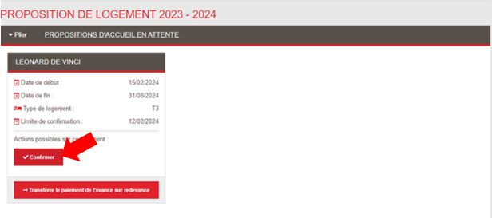
Then click on "Confirmer" / "Payer"
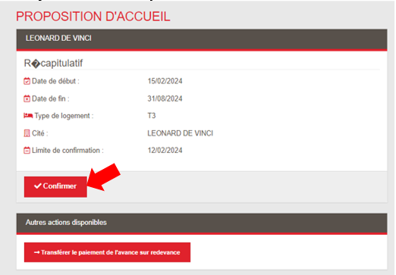

You will be directed to the following screen:

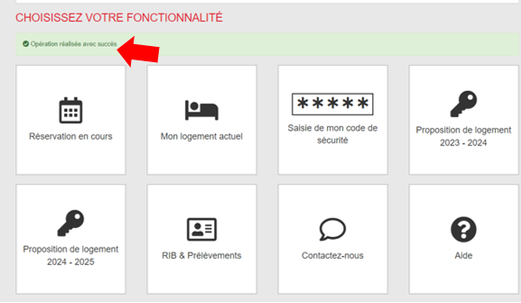
You will then receive the booking confirmation e-mail below with the address of the accommodation.
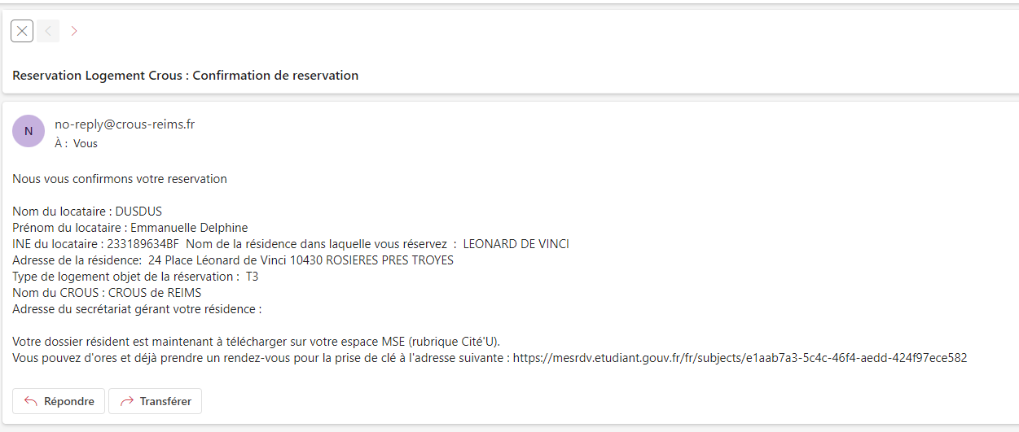

3 - Completing the rental file

Reconnect to MSE, then click on "Cité'U" to download the file.
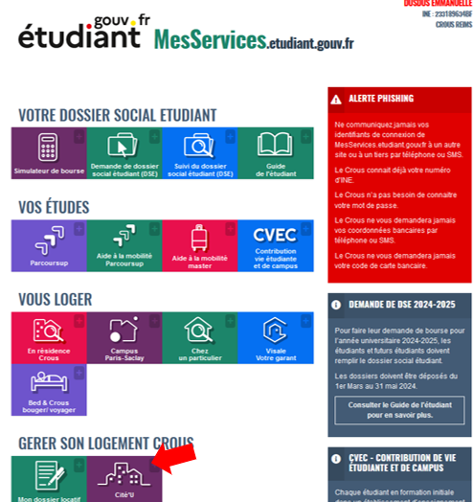

Select "CROUS DE REIMS" then click on "Ouvrir la page"
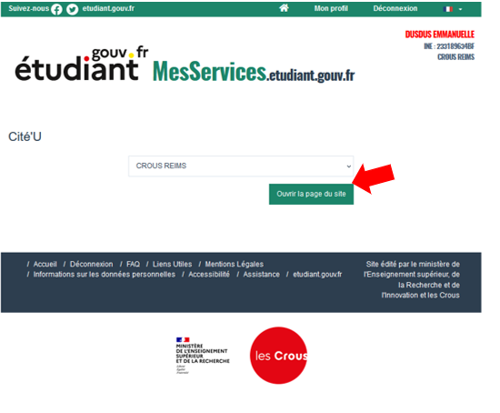
Click on " Réservation en cours"

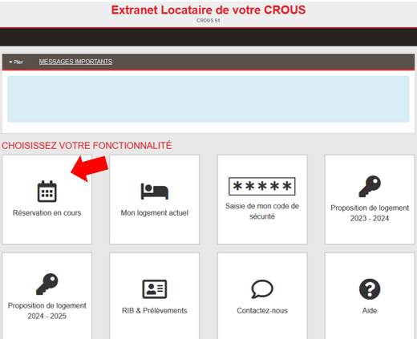

First, click on "Importer mes documents manquants"
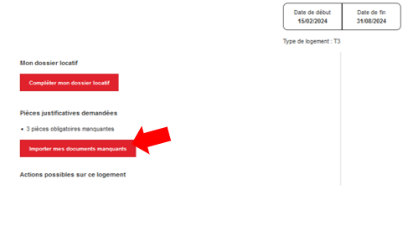
Insert the 3 required documents
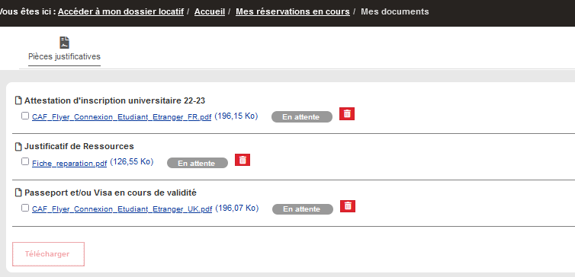
Go back to previous page
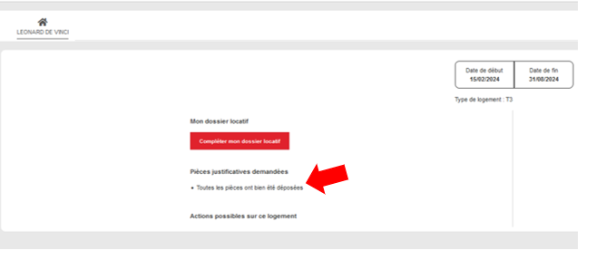

Then click on "Compléter mon dossier locatif"
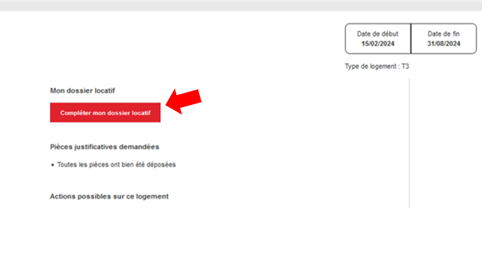
=> Check your mailbox to make sure you have received the booking confirmation email.
=> Connect to your account on "Mes Services Etudiant": https://www.messervices.etudiant.gouv.fr/ and click on "Mon dossier locatif".
=> To access your file, click on "Accéder au dossier" at the bottom of the page.
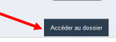
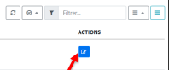
Open your tenant file, on the left

=> Read all the Mandatory documents in their entirety using the elevator (Décision d’admission – Annexe financière – Règlement intérieur) which allows you to: (*)

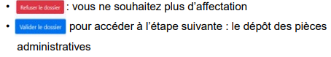
=> Enclose the required documents and validate
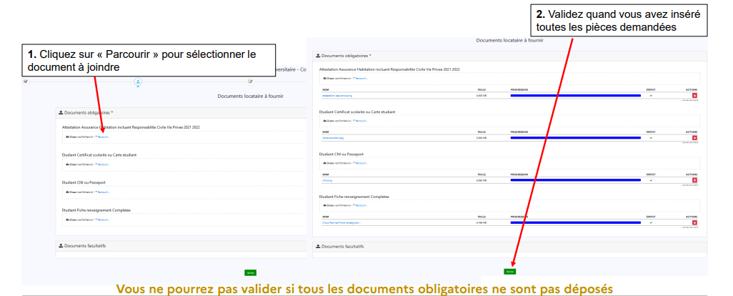
You will not be able to validate if all the required documents have not been submitted.
2. Confirm when you have inserted all the required documents.
1. Click on “Browse” to select the document to be attached.

=> Choose the type of guarantee between Visale - Guarantor Physical person - Institutional guarantor
- If Visale (Apply for VISALE Visa via the portal: https://www.visale.fr ): "Déposer le Visa de VISALE"

- If guarantor natural person
o Fill in the information concerning the guarantor

Download and complete the act of suretyship form and submit it:

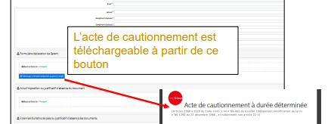
The act of suretyship bond can be downloaded from this button.

- Attach supporting documents concerning the guarantor

o Tax assessment or proof of absence of document
o Last 3 pay slips or proof of absence of documents
o Guarantor's identity document
o Proof of guarantor's address
o Proof of professional activity

- If Institutional guarantor (Student under contract)

o Attach the document provided in the reservation confirmation e-mail.

Please note that the guarantee must be signed by hand.

=> Validate the summary of your tenant file and confirm it.

At this stage, you can review the documents you have submitted and modify them if you have made a mistake, or cancel the rental file.

=> You can follow the progress of your file

- Once your file has been created, the status changes to "A valider" : “To be validated” => you wait for the file to be studied and validated by the residence.
- If one or more documents have been refused by the residence, you will receive an e-mail informing you of this. The status changes to "A Compléter" : "To be completed”.

o You have to reread all the documents to access the button "Accéder à mes pièces"
o You have to re scan all the pages of the file again.

-The document(s) to be modified are highlighted in red.
-You must delete the “erroneous” document and insert the correct one instead.

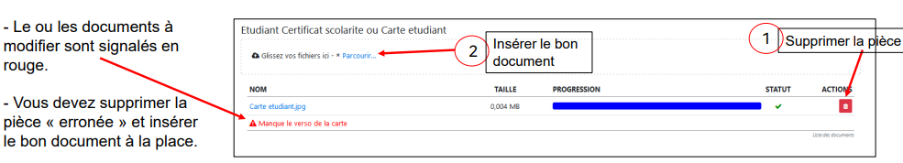
Insert the right document

Delete the document

=> Once you file has been validated by the residence, an e-mail is sent to you inviting you to sign it digitally.

=> Before you can sign, you need to reread it one last time, otherwise the “Valider” menu will not be visible.

- the admission decision,
- the financial appendix,
- the internal regulations.

=> Accept the conditions and click on "Continuer":

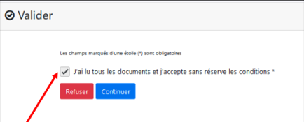

=> Proceed to the secure electronic signature with a code sent either by:

- SMS (Please note: it is valid only once!)
- Email

Choose the sending method and enter the security code (you have 15 minutes to enter the security code).

=> Click on "Signer"

Pay your security deposit

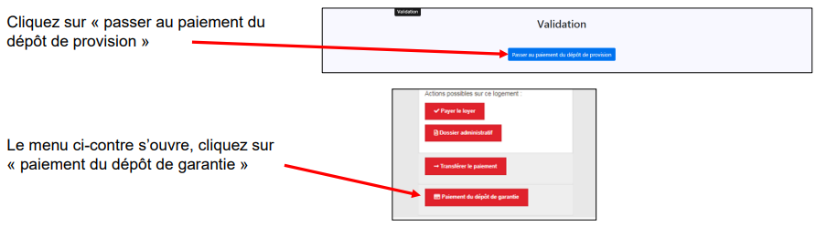
The opposite menu opens, click on "paiement du dépôt de garantie".
Click on "passer au paiement du dépôt de provision".

Once the security deposit has been paid, the status of the file changes to "Payé".

=> If you wish, you can terminate your rental file before sending the documents. Click on “Refuser le dossier” and give reasons for refusal, on Ebail and by filling in the withdrawal form.

The status of the rental file changes to “ Annulé par l'étudiant ”.

(*) If the validation button does not appear on "Mon dossier Locatif" after reading the documents, right-click on the gray bar and refresh the frame.
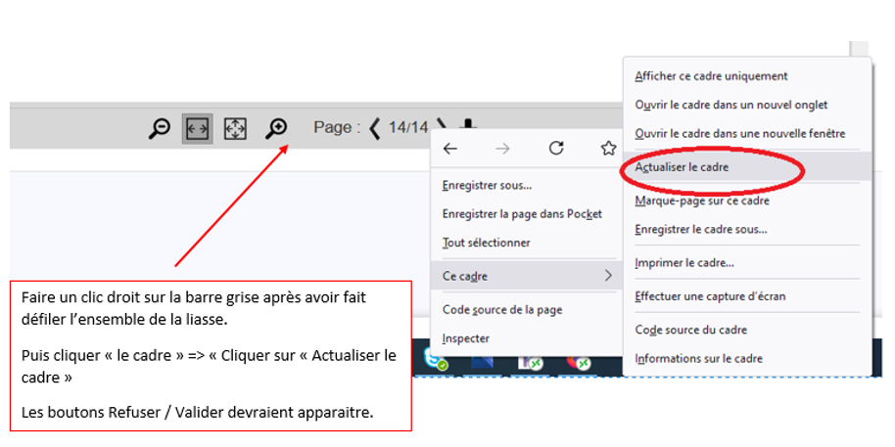
Right-click on the gray bar after scrolling through the entire bundle.
Then click on “Ce cadre” => “Click on ‘Actualiser le cadre’ : "Refresh the frame".
The “Refuser/Valider” buttons should appear.

