INTERSEMESTER PROGRAM
THE UNIVERSITE DE TECHNOLOGIE DE TROYES
The UTT is a public institution that depends directly on the French Ministry of Higher Education, Research and Technology. It has the advantage to combine all the assets of the engineering “Grandes Ecoles” and those of universities. It develops simultaneously and coherently three missions: education, research and transfer of technology.
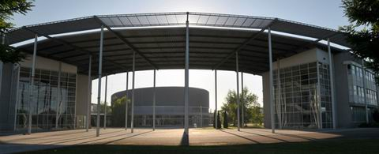
Troyes and the region
An hour and a half from Paris by road or rail, Troyes, once the regional seat of power for the Counts of Champagne, is a city rich in art and history. The old city center has kept intact its medieval architecture with its half-timbered houses and Champagne checkerboard façades of alternating dark-red and chalk bricks
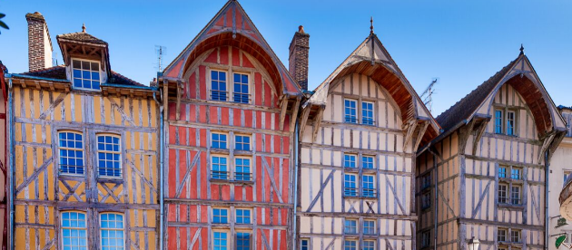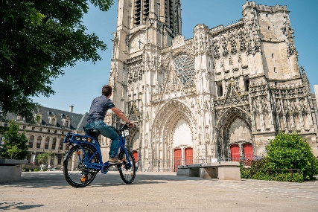

Learn French during our intensive course!
4 weeks intensive course from August 3rd to August 31th 2023
If you want to have an introduction to French language and French culture or want to improve your level in a multicultural atmosphere, this intensive program is made for you! 4-5 different levels from complete beginners to very good level!
Get 10 ECTS credits in 4 weeks: French as a Foreign Language (4 ECTS credits), Project-Management courses (6 ECTS credits - taught in English).
And get to know more about the UTT, Troyes and the Champagne region with the different visits and activities!
Course tuition fee are waived for exchange students coming from partner universities and depending on the exchange balance.
Accommodation, transportation food, activities and personal expenses are to be paid by the student
DRAFT CALENDAR OF CLASSES AND ACTIVITIES
(subject to changes)
Week 1
Thursday | August | 3 | Official Arrival Day
Friday | August | 4 | Classes
Saturday | August | 5 | Visit of Troyes
Sunday | August | 6 | Off
Week 2
Monday | August | 7 | Beginning of the FLE
Tuesday | August | 8 | Classes/ sport
Wednesday | August | 9 | Classes and dinner
Thursday | August | 10 | Classes/sport/ activities
Friday | August | 11 | Classes
Saturday | August | 12 | Off
Sunday | August | 13 | Off
Week 3
Monday | August | 14 | off
Tuesday | August | 15 | Off
Wednesday | August | 16 | Classes and dinner
Thursday | August | 17 | Classes/ sport/ activities
Friday | August | 18 | Classes
Saturday | August | 19 | Lake day
Sunday | August | 20 | Off
Week 4
Monday | August | 21 | Classes
Tuesday | August | 22 | Classes/ sport
Wednesday | August | 23 | Classes and dinner
Thursday | August | 24 | Classes/ sport/ activities
Friday | August | 25 | Classes
Saturday | August | 26 | Region trip
Sunday | August | 27 | Off
Week 5
Monday | August | 28 | Classes
Tuesday | August | 29 | Classes/sport
Wednesday | August | 30 | Classes and dinner
Thursday | August | 31 | Last day

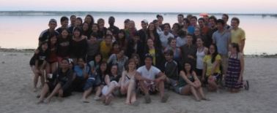
August 19th: Day at the “Forêt d’Orient”’s lake
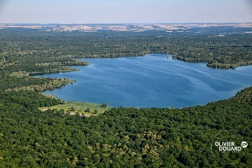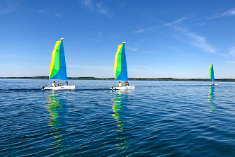
Around 50€ (price to be confirmed) - All included: Canoe / sailing and beach activities during all the day and barbecue for lunch.
August 26th: Champagne cellar, restaurant and visit of a medieval city
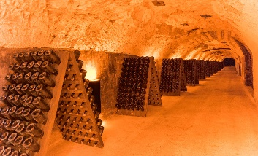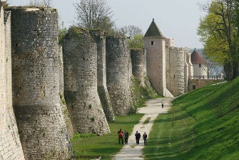
50€ (price to be confirmed): Visit of a champagne cellar AND French restaurant in Provins AND Visit of Provins (Unesco’s world heritage list) a medieval fair town - guided visit of the old town

REGISTRATION:
Students are registered to the activities upon payment that has to be done upon arrival and before the registration deadline stated under each activity (places are limited).
CANCELLATION:
REFUND WON’T BE POSSIBLE IN CASE YOU DECIDE TO DROP OUT OR MISS ANY ACTIVITY OR TRIP UNLESS YOU CAN PROVIDE A MEDICAL CERTIFICATE.

WINTER/SUMMER PROGRAM ARRIVAL

We organise the pick up once we have your arrival details (arrival form + copy of plane ticket). For students arriving from a non-European country, it might be possible to be met at the airport in Paris when they arrive during the official arrival days ( August 3rd and August 31th)
A package with local information including maps, tourist info, complete and detailed schedule of the program, etc., will be given to participants upon arrival in Troyes. A tour of the surroundings will be organized on arrival and tour of the city on the first Saturday.

INSURANCE

You will need to purchase several insurance which are mandatory to live in France and to study in the UTT: Home insurance, Health insurance and Civil liability (for more information about these insurances please consult our website).
The International Center will help you to get the required insurances.

ARRANGING ACCOMMODATION

The UTT can book accommodation for students coming from partner universities. If you want the International Relations Office to book your accommodation and welcome you at your arrival (at the airports in Paris or at the train station in Troyes), please follow the procedure on the online portal for applications.

More information?
Contact us
incoming@utt.fr

