Izly process

What is Izly ?
Izly is a mobile payment service used mainly by students in France. It allows users to pay for meals in university cafeterias, manage student account balance, and make secure payments using their phone or student card.

Simple: You can top up my account in just a few clicks, starting from 5€, via my mobile app or online. At any time, you can transfer money from your Izly account to your bank account.”
Convenient: You can pay on campus using your student card or the Izly app.
Universal: You can use your Izly account to pay for all your on-campus purchases.
Secure: Izly was developed for CROUS by Xpollens, a BPCE subsidiary (France’s second-largest banking group). Your personal and banking data are protected and never stored on your device, and all online transactions require password verification.

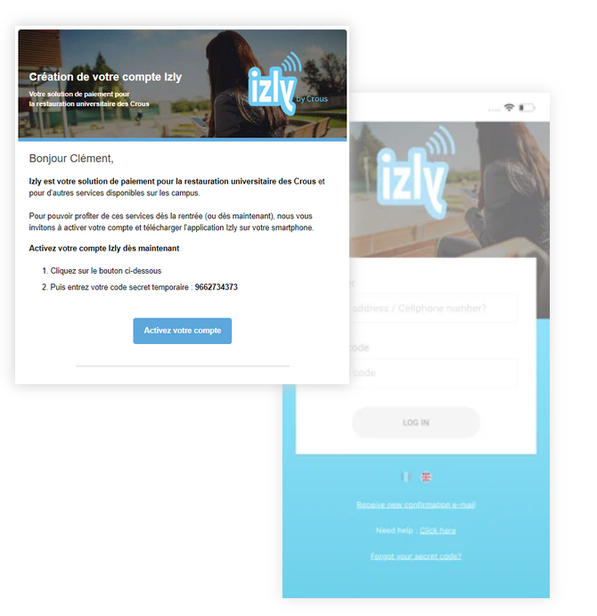
As a student here at UTT you can also add money and use this app. Below you will find the complete process for creating your account and using the app.

STEP 1: Activate your account
Using the temporary password provided in your Izly activation email, you can access your account in just a few steps online.
To take full advantage of all Izly services, download the mobile app from the App Store or Google Play.”

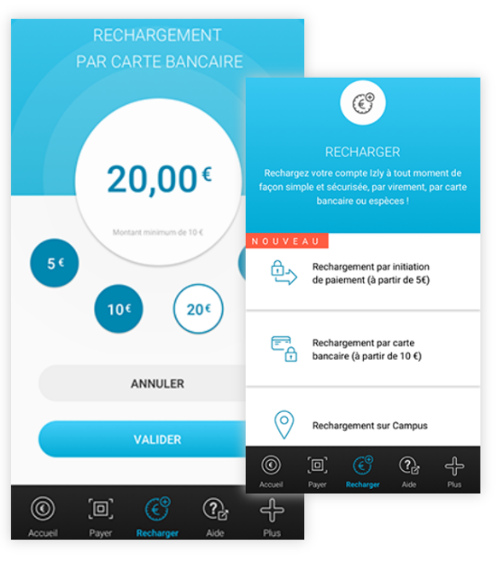

STEP 2: Top up your account
On the app home screen or online, simply click ‘recharger and fund your Izly account in just a few clicks using the available options.

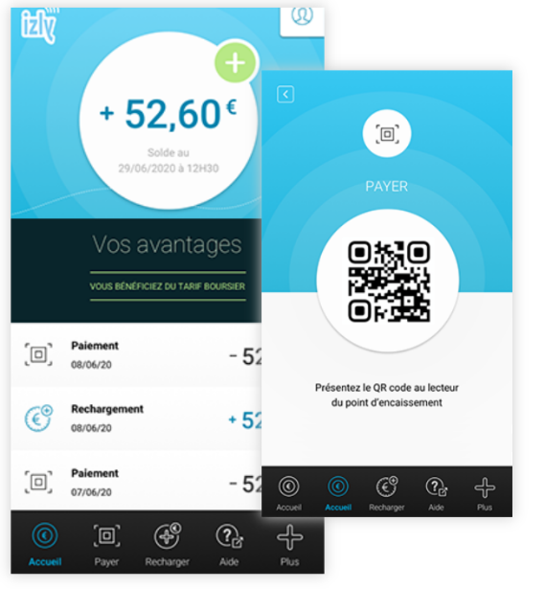
STEP 3: Pay for your meal
To pay with your phone, open the app, tap ‘Payer’, generate a QR code, and scan it at the cashier in your CROUS cafeteria.
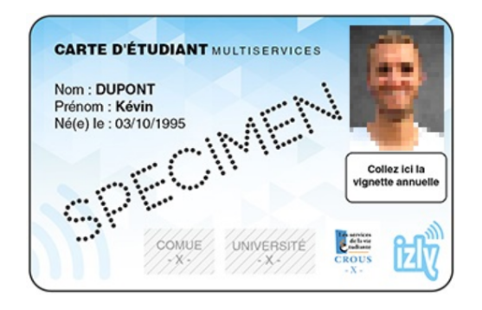
You can also pay using your contactless student card.

It’s done!! 😄

