French Health Insurance
To be paid back at most, students can subscribe a complementary medical care insurance (“une mutuelle”). Students can subscribe to a “mutuelle” once in France (they will pay it every month). We encourage you to take it.
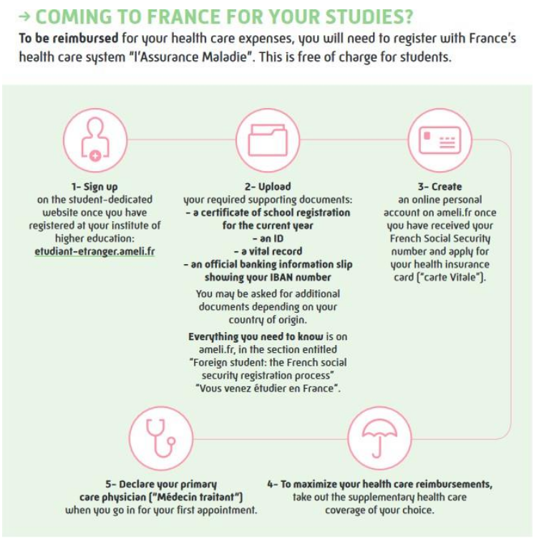
The social security program also offers its own complementary medical care insurance upon request, once your subscription to the main healthcare system has been completed and validated (which can take several months).
- European students: must produce a European Health Insurance Card.
- Students from Quebec: must produce the SE401Q106 form duly validated from their home country.
- Non-European students (and European students who do not have a European Health Insurance Card and Students from Québec that do not have the SE401Q106 form): must register online to the French National Health Insurance.
- Students coming for the French Intensive Course only: must have their own health insurance to cover them whilst in France (except students with the European Health Insurance card).
- Students under 18: must provide a medical certificate on arrival to the UTT + a consent for medical treatment. They must prepare these documents in their home country and bring them in France.

Warning: Upon arrival, students must submit a medical certificate, delivered by the
doctor from the home country and a medical sheet information (both documents are
available on our online plateform-moveon). It is the sole responsibility of the students to
verify that they have all necessary insurances for the whole duration of their studies at
the UTT/of their stay in France.

